NEVA 2021
International Maritime Exhibition and Conference for Commercial Shipping, Shipbuilding, Offshore Energy, Ports, Inland Waterways and Oceanography
SPONSOR & PARTNER PACKAGES

NEVA Exhibition partner or sponsorship is a prestigious status assigned to successful companies recognized as key players in the maritime industry and business community. Partner or sponsor status opens up the most effective opportunities for promoting your company at NEVA 2021.
Sponsorship Opportunities | Sponsorship & Partner Categories
Service Package | General PARTNER (exclusive status) | Official PARTNER  (3 packages) | PARTNER
Granting of PARTNER’s status, with the right to use this status in all presentation and promotional materials
Participation of PARTNER’s representative in the Exhibition opening ceremony
Presentation of PARTNER’s company representative within the framework of the conference programme | Participation in the business programme: plenary meeting, conferences, round tables | Participation in the business programme: conferences, round tables | Participation in the business programme: conferences, round tables
Conference room for arrangement of PARTNER’s side-events
Arrangement of PARTNER’s personal contacts with the Exhibition participants of interest
Placement of PARTNER’s logo and status on the advertising banners and/or posters in the venues of the Exhibition and Conference official events
Placement of PARTNER’s logo on the information signs during the Exhibition
Placement of PARTNER’s ads on the indoor advertising cube at the entrance to F/G halls (2 pcs)
Placement of PARTNER’s ads on the advertising pillars in the passage-way (close to the entrances to the Exhibition) (at least 6 pcs)
Placement of PARTNER’s ads on the arch of the entrance to F/G halls (2 pcs)
Placement of PARTNER’s logo on the indoor advertising surfaces of the Forum venue
Placement of PARTNER’s logo on the front of the registration stand
Placement of PARTNER’s ads on the façade frames in the passage-way at the entrance, 5 × 9 m
Placement of PARTNER’s ads on the light boxes at the entrance, 1.2 × 1.8 m (at least 8 pcs)
Placement of PARTNER’s ads on the light boxes in the passage-way entrance space, 1.2 × 1.8 m
(8 pcs)
Placement of PARTNER’s ads on the outdoor advertising cube at the entrance to H/G halls
(2 pcs)
Placement of PARTNER’s logo and status on the outdoor advertising surfaces of the Forum venue
Placement of PARTNER’s logo and status in the printed information materials of the event (programme, invitations, poster, promotional handouts, participants catalogue) issued after conclusion of the sponsorship agreement
Placement of PARTNER’s information in the Exhibition Official Catalogue
Placement of PARTNER’s advertising module in the Exhibition Official Catalogue and Guide
Placement of PARTNER’s logo, name and status on makeups within the framework of the Exhibition media campaign
Placement of PARTNER’s logo in all advertising modules of the Exhibition published in print media after conclusion of the sponsorship agreement.
Placement of PARTNER’s logo and information in bulk e-mail to contacts from the industry database (more than 40,000 addresses)
Placement of PARTNER’s logo and information on the Exhibition website (releases, news)
Broadcasting of PARTNER’s video presentation / promotional video on plasma screens in EXPOFORUM Convention and Exhibition Centre
Shooting of video invitation to the Exhibition and its posting on the website
Shooting of the interview during the Exhibition and its posting on the website. Adding fragments from the interview to the summary video about the Exhibition
Placement of PARTNER’s logo and status in the summary video about the Exhibition
Broadcasting of commercials on the monitors in branded shuttle buses. (Periodic broadcasting of video commercials with audio in all shuttle buses)
Broadcasting of PARTNER’s audio advertisements in EXPOFORUM Convention and Exhibition Centre
Adding of PARTNER’s advertising materials to the participant package
Distribution of PARTNER’s advertising and information materials at the registration stand
Catering services for all days of the Exhibition (lunches, coffee breaks)
Placement of PARTNER’s logo and status on the reverse side of badges, with an option of badge lanyards branding (provided by the partner)
Right to carry out promotion during the Exhibition (format shall be agreed with the Organiser)
Invitations for PARTNER | not limited | 300 | 100
Delegate packages | 3 vip packages, 10 standard packages | 1 vip package, 5 standard packages | 1 vip package, 2 standard packages
Invitations for PARTNER to the Exhibition Opening Reception (Gala dinner) | 3 | 2 | 1
Reserved VIP parking lot
Submission of summary report to PARTNER
Price of the package | upon request | upon request | upon request
Please note that the price of partner & sponsorship packages may be subject to change. We will be glad to consider your suggestions and develop an individual package for your organization, including the possibility of holding your own event within the framework of the Exhibition and Conference programme.
For more information, please contact the Organizer’s Office:
NEVA-International LLC
Tel: +7 (812) 321-2676
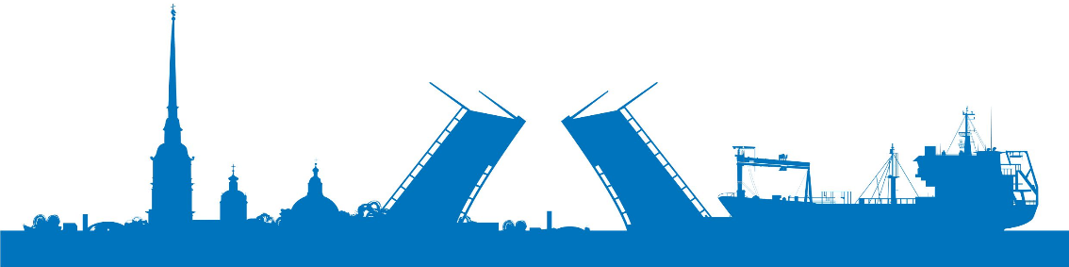
e-mail: info@nevainter.com

